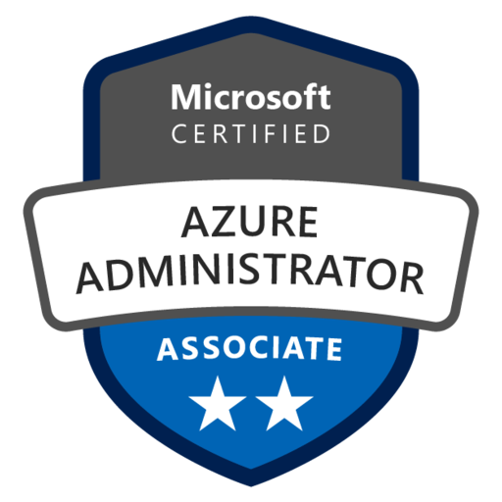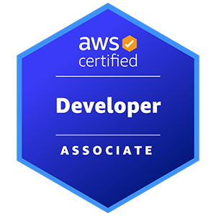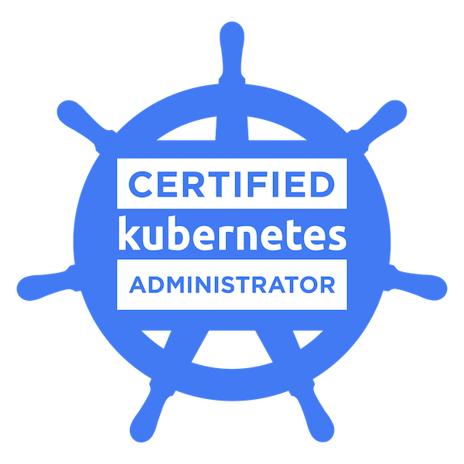

**Meghana Bathula**

**Sr. DevOps Azure/AWS Cloud Engineer**

**EMAIL:** [**Meghana.bathula221429@gmail.com**](mailto:Meghana.bathula221429@gmail.com)

**PHONE: 2602554496**

**LinkedIn url:** [**www.linkedin.com/in/meghana-bathula-114a9a173**](http://www.linkedin.com/in/meghana-bathula-114a9a173)

Experienced DevOps AWS/Azure Cloud Engineer with 10+ years in IT. Specializing in DevOps, AWS Cloud, CI/CD, and Linux. Certified in Azure and AWS. Proficient in AWS/Azure services, scripting, containerization, and orchestration. Skilled in end-to-end SDLC execution, automating deployments, and collaborating with cross-functional teams. Strong in Linux, scripting, and containerization tools.

**PROFESSIONAL ACHEIVEMENTS:**

* Experienced in identifying and resolving issues related to data connections, visualization rendering, and dashboard performance to ensure a smooth user experience using **quicksight.**
* Developed and managed AWS infrastructure using a wide range of services, resulting in a 30% reduction in infrastructure provisioning time.
* Put into action disaster recovery mechanisms using AWS services, ensuring high availability with a 99.9% uptime rate.
* Managing and deploying Synapse environments, version control of scripts and configurations, and automating deployment pipelines for Synapse objects.
* Led the seamless migration of a legacy system to Azure, elevating scalability and achieving a remarkable 40% improvement in system responsiveness.
* Automated code deployment across diverse environments, reducing manual errors by 50% and ensuring consistent releases.
* Integrated DevOps tools seamlessly with cloud platforms, resulting in enhanced agility and a 25% reduction in deployment cycles.
* Successfully migrated applications to **Azure IaaS** and **PaaS**, optimizing resource utilization and reducing hosting costs by 30%.
* Proficiently leveraged **OpenShift**(OCP by Red Hat) alongside build tools such as Maven and Ant to craft deployable artifacts like War and Ear from source code, showcasing expertise in streamlining the application development lifecycle.
* Demonstrated adeptness in orchestrating and supervising complex projects within the Docker ecosystem. Effectively navigated diverse environments, harnessing Docker's fundamental features and components like containerization, image creation, networking, volume management, and Docker Compose for streamlined application deployment.
* Accomplished seamless migrations of legacy infrastructures to Docker, unlocking enhanced scalability and yielding remarkable improvements of up to 40% in system responsiveness. Leveraged Docker's capabilities to efficiently encapsulate applications and ensure consistent performance across various environments.
* Proficiently managed intricate projects in Kubernetes, overseeing diverse environments and leveraging its core features and components such as pod orchestration, service discovery, scaling, rolling updates, and resource management.
* Led implementation and acted as primary SME for Octopus Deploy, including Nuget & TeamCity integration.
* Successfully migrated a legacy system to Kubernetes, boosting scalability and achieving a significant 40% enhancement in system responsiveness.
* Led complex projects, leveraging Terraform's capabilities for cloud provisioning and resource management.
* Transformed traditional infrastructure, achieving a 35% provisioning time reduction.
* Mastered multi-cloud provisioning (AWS, Azure, Google Cloud) for optimized, secure networks.
* Versioned infrastructure changes for reproducibility and seamless team collaboration.
* Optimized resources using modules, enhancing efficiency and maintaining cost-effectiveness.
* Prioritized security via IAM, encryption, and regular audits for a robust infrastructure.
* Enabled collaborative workflows, integrating Terraform with Git for streamlined teamwork.
* Automated testing ensured reliable deployments and minimized errors.
* Managed MongoDB, PostgreSQL, Oracle, and MS SQL Server databases, optimizing query performance and achieving a 20% reduction in response times.
* Demonstrated proficiency in network protocols like FTP, SSH, HTTP, and HTTPS, ensuring smooth communication across diverse systems.
* Familiar with various bug tracking tools like **JIRA, Rally, Remedy, HP Quality Center**, and **Fisheye**.
* Orchestrated a collaborative and communicative team environment, elevating junior colleagues' technical expertise by 40% through tailored mentorship programs and hands-on guidance, resulting in streamlined project execution and enhanced productivity levels.
* Provided expert technical support for AWS and Azure cloud environments, ensuring system reliability and performance.
* Acted as SME for numerous applications
* Collaborated with development teams to troubleshoot and resolve cloud-related issues for seamless application functionality.
* Monitored cloud infrastructure, responding to alerts promptly and implementing proactive measures to prevent downtime.
* Implemented security best practices, managing IAM roles and policies, and conducting regular security assessments.
* Assisted in disaster recovery planning and executed backup strategies, ensuring high availability of critical systems.
* Contributed to optimizing cloud costs, utilizing tools like AWS Cost Explorer and Azure Cost Management.
* Utilized tools like Kanban boards to visualize work in progress, track tasks, and optimize workflow, enhancing transparency and efficiency.

**PROFESSIONAL EXPERIENCE .   
  
Multi-Cloud DevOps Engineer**

**Shure, Texas   
 Aug 2022 – Jan 2024**

* Collaborate with cross-functional teams to optimize Build and Deployment processes across development and production phases.
* Develop Jenkins pipelines tailored for Node.js, Maven, and Spring Boot applications, ensuring efficient and reliable delivery.
* Orchestrated Jenkins pipelines to automate the building and packaging of microservices, with Packer playing a crucial role in image provisioning. This approach resulted in efficient and scalable microservice deployment.
* Manage DNS services and domain configurations, ensuring seamless connectivity and accessibility.
* Create Jenkins Utility jobs to facilitate bulk service deployment, streamlining operational efficiency.
* Generate Ansible templates through Jenkins jobs, simplifying and accelerating infrastructure provisioning.
* Design Ansible playbooks for microservices deployment, establishing consistent and scalable infrastructure setups.
* Provide 24/7 on-call production support across GCP environments to ensure system reliability and responsiveness.
* Monitor system performance using tools like Dynatrace, tailored for GCP, to proactively address potential issues.
* Successfully served as a Scrum Master, facilitating daily stand-ups, sprint planning, sprint reviews, and retrospectives to ensure efficient team coordination and continuous improvement while leveraging GCP's capabilities.
* Utilize Docker Swarm to containerize microservices, enhancing deployment flexibility and management.
* Research, implement, and maintain Docker Swarm for advanced container orchestration.
* Automate AWS tasks by integrating Docker and Ansible, increasing operational effectiveness.
* Swiftly troubleshoot and resolve microservices issues to maintain optimal performance.
* Implement Continuous Delivery pipelines utilizing Jenkins, Docker, GitHub, and AWS AMIs.
* Oversee build results in Jenkins and deploy applications using established workflows.
* Develop automated Ansible modules and playbooks for streamlined infrastructure management.
* Efficiently set up new server instances on AWS, configuring security groups and Elastic IP.
* Create, manage, and deploy builds using Ruby (Ansible Playbook) and shell scripting.
* Support and enhance the Software Development Life Cycle (SDLC) by deploying web applications through Docker containers.
* Successfully employed Red Hat's project management tools and methodologies, including JIRA, SFTP, SSH, HTTP, HTTPS, and CONNECT DIRECT, to optimize project workflows. This strategic approach led to a significant 30% enhancement in task monitoring, team collaboration, and overall project management efficiency.
* Provide 24/7 on-call production support to ensure system reliability and responsiveness.
* Monitor system performance using tools like Dynatrace to proactively address potential issues.
* Successfully served as a Scrum Master, facilitating daily stand-ups, sprint planning, sprint reviews, and retrospectives to ensure efficient team coordination and continuous improvement.
* **AWS, CentOS, Jenkins, Bitbucket, Nginx, Artifactory, Maven, Groovy, Docker, Ansible, Java, Shell scripts, Ansible Tower, Dynatrace.**

**Azure DevOps Engineer**

**London Computer Systems**

**Apr 2021 – July 2022**

* Designed and implemented Azure Key Vaults to secure certificates and secrets, enhancing data protection.
* Strengthened Azure Network security by configuring inbound and outbound traffic rules.
* Integrated Terraform with secrets management solutions like Azure Key Vault to securely store and retrieve sensitive credentials and configuration data required for provisioning resources.
* Leveraged Azure CLI for infrastructure automation, streamlining deployment processes.
* Monitored Azure resources using Azure App Insights and managed subscriptions using PowerShell scripts.
* Configured and maintained Azure Storage Firewalls and Virtual Networks, ensuring secure data transmission.
* Implemented DevSecOps practices by automating security checks across the development lifecycle and utilizing Azure tools for vulnerability detection.
* Established Single Sign-On (SSO) access for SaaS applications through Azure Active Directory (AAD), enhancing user authentication.
* Orchestrated migration and re-platforming of applications using OpenShift developed by red hat, resulting in improved scalability and performance.
* Managed containerized applications using Azure Kubernetes Service (AKS), optimizing application performance.

Utilized Azure Kubernetes Service (AKS) in Continuous Integration and Continuous Delivery (CI/CD) pipelines with Azure DevOps, Docker, and Helm.

* Deployed and configured Istio service mesh to enhance microservices communication, security, and observability within a containerized environment.
* Integrated AKS into end-to-end CI/CD pipelines, enhancing the efficiency of DevOps workflows.
* Developed and integrated Terraform templates for automating Azure IAAS VMs and VMSS delivery.
* Utilized Packer to create and manage base images, which were then utilized in Jenkins CI/CD pipelines, ensuring a consistent and reliable application deployment process. This approach enhanced the quality and speed of software delivery.
* Integrated Docker container-based testing into Jenkins CI flow, collaborating with GIT and JIRA for efficient builds.
* Highlight any customizations or extensions made to Istio to meet specific project requirements or to enhance its functionality.
* Implemented Istio's traffic splitting functionality to gradually roll out new features or versions of microservices, minimizing the risk of errors during deployment.
* Executed CI/CD pipelines in Jenkins for Continuous Integration and Continuous Delivery, ensuring smooth application deployment.
* Managed Jenkins pipelines for building microservices and storing Docker images.
* Orchestrated Kubernetes clusters for efficient application deployment, scaling, and management.
* Integrated Istio with external services and APIs to secure and monitor interactions beyond the Kubernetes cluster, extending the benefits of Istio's service mesh to external dependencies.
* Configured Splunk for monitoring server application logs, enabling timely issue detection.
* Standardized server application images using Packer to ensure consistency across instances. This standardization simplified Splunk configuration for monitoring server application logs, enabling proactive issue detection and resolution.
* Pioneered the establishment of a collaborative and transparent team environment within the framework of Red Hat Enterprise.
* Integrated JIRA with GIT repositories and implemented Azure Boards for effective issue tracking and project management.
* Integrated Terraform with version control systems (e.g., Git) and established versioning best practices to track changes and promote collaboration among team members.
* Embraced changing requirements by adjusting sprint plans and priorities based on evolving project needs, fostering a responsive and customer-centric approach.
* **Azure, Azure DevOps, Jenkins, WebLogic, Nexus, JIRA, Ansible, Oracle, Terraform, OpenShift, Kubernetes,** **Prometheus, Python, Maven, Java, GitHub, Linux, ELK, GIT, LDAP, NFS, NAS, MS SharePoint, Windows, Splunk, PowerShell, Shell Scripts, OpenStack, Docker, ServiceNow**

**AWS DevOps Engineer**

**Kohl's Digital, Wichita**

**Oct 2020 – Mar 2021**

* Spearheaded the implementation of Continuous Integration (CI) and Continuous Delivery (CD) processes across various environments, including development, Quality Analysis, staging, and production, with a strong focus on Azure DevOps for pipeline orchestration.
* Swiftly resolved build issues during Jenkins processes by collaborating closely with developers, ensuring smooth development and deployment workflows on Azure infrastructure
* Managed end-to-end server engineering, administration, patching, and support for Red Hat Enterprise Linux servers running on Azure virtual machines.
* Orchestrated storage solutions on AWS, utilizing EBS, S3, and Glacier for efficient data synchronization to Glacier. Meanwhile, in the Azure environment, Azure Blob Storage and Azure Data Lake Storage were employed for data management.
* Utilized Istio's fault injection capabilities to simulate real-world failures in a controlled environment, enabling comprehensive testing of service resilience and error-handling mechanisms.
* Successfully executed a complex Big Data ETL streaming pipeline for seamless migration of transactional data to AWS Cloud, while exploring Azure Data Factory and Azure Databricks for similar tasks within Azure.
* Utilized AWS Kinesis Event Streaming Platform, Stream sets, and AWS EMR for data movement, with Azure Event Hubs and Azure Stream Analytics playing a pivotal role in Azure's real-time data processing.
* Configured Elastic Beanstalk for streamlined application deployment and testing processes, enhancing developer productivity, while also exploring Azure App Service for similar capabilities.
* Orchestrated multi-cluster deployments with Istio, enabling seamless communication and load balancing across geographically distributed microservices, enhancing availability and fault tolerance.
* Designed and implemented robust security measures tailored to specific project requirements, integrating Azure Security Center and Azure Sentinel for threat detection and response.
* Managed and configured Azure AD Connect, Azure AD Connect Health, and Microsoft Azure Active Directory, ensuring effective user account management and security, while also evaluating Azure AD features for identity management.
* Oversaw user profiles, rights, disk space, and process monitoring using Active Directory in the Azure Active Directory environment.
* Deployed High Availability (HA) models utilizing both Azure Classic and Azure Resource Manager for enhanced resilience and reliability, exploring Azure Availability Zones for fault tolerance.
* Developed and implemented a comprehensive Continuous Integration (CI) system, configuring Jenkins servers, nodes, and scripts (Perl & Python), and setting up VMs (Windows/Linux) on Azure virtual machines.
* Automated deployments on AWS using IAM roles, policies, and Jenkins-AWS integration with EC2 instances, while considering Azure automation options like Azure Automation and Azure Resource Manager templates.
* Leveraged Jenkins for continuous integration in a Master-Slave Architecture, conducting builds on remote RHEL servers hosted on Azure infrastructure.
* Installed and configured Docker using Docker Toolbox and established Kubernetes (EKS) for effective container orchestration, while also exploring Azure Kubernetes Service (AKS) for Azure-based container orchestration solutions.
* Configured auto-scaling policies for EKS worker nodes based on metrics like CPU utilization and memory usage in AWS, and considered similar capabilities offered by Azure Kubernetes Service (AKS) for dynamic resource allocation based on demand.
* **AWS, Azure, Git, Jenkins, Ansible, Docker, Kubernetes (EKS), Nagios, Splunk, Linux, Shell, Python, GitHub, SVN, MySQL, AWS Lambda, ELK Stack.**

**DevOps Engineer**

**Fiserv, New Jersey**

**Feb 2018 – Sep 2020**

* Spearheaded DevOps migration and automation initiatives, optimizing build and deployment systems for enhanced efficiency.
* Advised and guided clients on best practices for effective Build and Release Management Implementation.
* Played a crucial role in resolving **Source Code Management (SCM)** and build issues, including merge conflicts, compilation errors, and missing dependencies.
* Ensured smooth development processes by swiftly addressing technical challenges.
* Utilized **Ansible playbooks** to provision virtual and physical instances, manage configurations, and implement patching.
* Leveraged **Ansible**, **Python**, **Perl**, and **shell scripting** to automate processes, ensuring consistency and adherence to organizational policies.
* Collaborated within an agile development team to deliver comprehensive Continuous Integration and Continuous Delivery (CI/CD) solutions.
* Employed tools like **Puppet** and **Jenkins** to establish end-to-end CI/CD pipelines, enhancing software delivery.
* Developed Puppet manifests and modules for automated deployment, seamlessly integrating them with Jenkins to enable Continuous Deployment (CD).
* Streamlined application deployment processes for consistent and reliable results.
* Configured and monitored multi-platform servers, ensuring their stability and efficient operations.
* Maintained a robust server environment to support development and deployment activities.
* Set up AWS infrastructure components including VPC, EC2, RDS, IAM, Security Groups, using Cloud Formation templates.
* Managed the deployment of EC2 instances across diverse Linux and Windows platforms within AWS.
* Implemented security measures for EKS clusters, including network policies, IAM roles, and VPC configurations, to enhance isolation and protect sensitive workloads.
* Created and managed Continuous Integration and Continuous Deployment (CI/CD) processes, orchestrating deployments using Jenkins/Hudson and GitHub.
* Proficiently executed Blue/Green and Canary deployments to minimize downtime and reduce deployment risks.
* Developed and documented deployment strategies that contributed to seamless releases.
* Enforced code coverage and quality through plugins such as **FindBugs**, **Checkstyle**, and **Maven/Hudson**.
* Conducted Security Scans, tracked defects, and reported issues using tools like **SonarQube**, **Bugzilla**, and **JMeter**.
* Ensured code quality and security in releases, contributing to a robust and reliable software lifecycle.
* Set up monitoring and logging solutions within EKS using tools like **CloudWatch** and **Fluentd**, enabling real-time visibility into cluster health and application performance.

**Java, Maven, ANT, Gradle, Groovy, GIT, SVN, Puppet, Jenkins, Ruby, Splunk, JMeter, Tomcat, SonarQube, Bugzilla, Shell and Perl Scripts, Ansible, PowerShell, Nexus, RHEL 5.x/6.x.**

***Client: Reliance Industries, Mumbai, India   
 Nov 2012 – Dec 2016***

***Role: Linux Administrator***

***Responsibilities:***

* Administered a range of **Red Hat versions** (3.0 to 6.0 AS/ES), efficiently troubleshooting hardware, OS applications, network issues, and performance challenges.
* Ensured seamless system operation by swiftly resolving issues and maintaining optimal performance levels.
* Deployed Linux and application server patches, contributing to system security and performance enhancement.
* Leveraged Red Hat Linux Kernel tuning techniques to optimize system performance and responsiveness.
* Installed and configured **Sendmail** and **Postfix** mail servers, facilitating efficient email communication.
* Managed mail server operations to ensure reliable email delivery and reception.
* Managed Virtualization using **VMware** and **Linux**, ensuring the effective setup and management of virtual environments.
* Optimized resource utilization and maintained the stability of virtualized systems.
* Designed and implemented robust package and patch management strategies, enhancing system stability and security.
* Ensured that systems were up-to-date with the latest software updates and security patches.
* Developed **Linux System Imager** and **Shell scripts** to automate maintenance tasks and streamline system management.
* Improved operational efficiency through the automation of routine processes.